Faculty of Science, Engineering and Technology





**Interface Design and Development**

Warm Up Exercise: Getting Bootstrap Up and Running

**Overview**

Create the classic “Hello World” web page using the Bootstrap framework. This will help ensure that you have the framework installed correctly, and are ready to move on with creating web applications.

**Purpose:** Install and test the framework needed to get started.

**Task:** Create your own Hello World web page with Bootstrap.

**Time:** This task should be completed in your first lab class and submitted for feedback before the start of week 3.

**Resources:**

* + - Bootstrap https://getbootstrap.com/docs/3.4/
    - Getting started https://getbootstrap.com/docs/3.4/getting-started/#download

***Submission Details***

**No submission required** for this task.

Make sure that your task has the following:

* The Hello World is HTML5 compliant.
* Demonstrate understanding of using the Bootstrap framework.

**Instructions**

The first task includes the steps needed for you to install the framework you will need in this unit. You will then use the Bootstrap framework to create the ‘Hello World’ web page.

1. Download and install the framework you need to get started. Ensure that you have:
   * Installed Bootstrap (https://getbootstrap.com/docs/3.4/getting-started/#download)
   * Installed JQuery (<https://jquery.com/download/>)

You should have the following files stored in appropriate folders

framework/

├── css/

│ ├── bootstrap.css (can choose to use only the

│ ├── bootstrap.css.map minified version)

│ ├── bootstrap.min.css

│ ├── bootstrap.min.css.map

│ ├── bootstrap-theme.css

│ ├── bootstrap-theme.css.map

│ ├── bootstrap-theme.min.css

│ └── bootstrap-theme.min.css.map

├── js/

│ ├── bootstrap.js

│ ├── bootstrap.min.js

│ ├── jquery.js (rename the JQuery files to omit

│ └── jquery.min.js the version number)

└── fonts/

├── glyphicons-halflings-regular.eot

├── glyphicons-halflings-regular.svg

├── glyphicons-halflings-regular.ttf

├── glyphicons-halflings-regular.woff

└── glyphicons-halflings-regular.woff2

**Note:** You may also want to download scripts to enable legacy versions of IE to fully support HTML5 and CSS3, and place them in the js folder. These are html5shiv <https://cdnjs.com/libraries/html5shiv> and respond <https://cdnjs.com/libraries/respond.js/>

**Tip:** You can also use direct link to specific versions of the scripts in your HTML file.

<!-- HTML5 shim and Respond.js for IE8 support of HTML5 elements and media queries -->

<!-- WARNING: Respond.js doesn't work if you view the page via file:// -->

<!--[if lt IE 9]>

<script src="https://oss.maxcdn.com/html5shiv/3.7.2/html5shiv.min.js"></script>

<script src="https://oss.maxcdn.com/respond/1.4.2/respond.min.js"></script>

<![endif]-->

1. If you don’t already have one, make a directory (i.e., a ‘folder’) to store your framework (e.g. Documents/cos30043). On a Swinburne computer you may wish to use a directory on your student drive or a USB storage device.

**Note:** You may will to use the framework in most of your lab tasks. You can either keep a single copy for the framework files for all you lab tasks, or replicate a copy of the framework files for each task.

**Tip:** Replicating the framework files makes your work portable, however this will be at the expense of storage space. A possible folder organisation will be

document/

└── cos30043/

├── lab01/

├── lab02/

│ ├── css/

│ ├── fonts/

│ └── js/

├── lab03/

│ ├── css/

│ ├── fonts/

│ └── js/

:

└── labnn/

├── css/

│ ├── fonts/

└── js/

1. Create a new file and enter the code for the Hello World program. It should appear shown here.

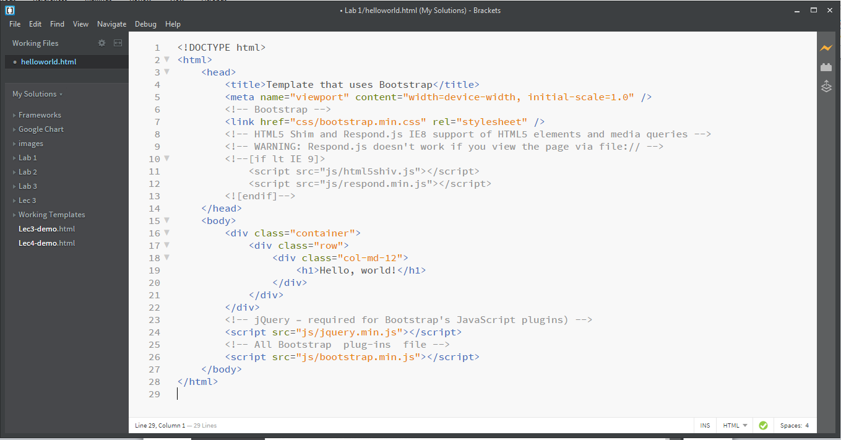

**Note:** The “Errors: 2” in red refers to the Brackets not your code. (if any)

1. Save the file as helloworld2.html in your lab02 directory.

**Note:** The html file will be interpreted and rendered into a webpage when open by a browser.

1. Click on the Live Preview icon to view the web page.

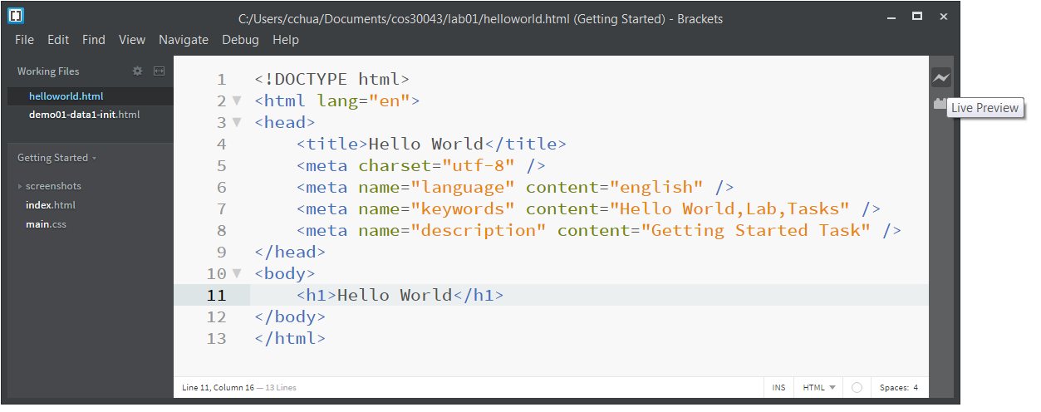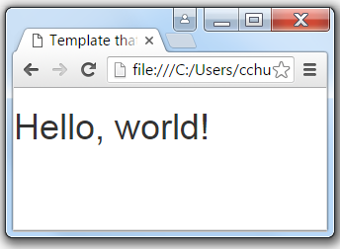

1. Answer the following questions in the answer sheet provided in the **resources** for this task.
2. Is the font type in helloworld2.html similar to helloworld.html?
3. What happens if you remove <div class="container"></div>?
4. What is the purpose of <div class="container"></div>?

Now that the task is complete you can submit it for assessment, which will help prepare it for your portfolio.